Mechatronics and Industrial Internet of Things

IIoT-Based Wireless Environmental Monitoring System for Smart Industries

PROJECT REPORT

BHAVESH PRAKASH G - 24MER005
VASANTHAN B – 24MER060
PRABHUKUMAR N – 24MER40
AJAY PRABHAV A – 24MER003
SANTHAKUMAR M – 24MEL065
DEEPAK C – 24MEL069
- Project Overview:
The Wireless Environmental Parameter Monitoring System for Smart Industries is an Industrial Internet of Things (IIoT) based solution designed to monitor environmental conditions such as temperature, humidity, and air quality in industrial environments. The system uses sensors to collect real-time environmental data and an ESP8266MOD Wi-Fi module to process and transmit information wirelessly. By continuously monitoring these parameters, industries can ensure worker safety, maintain optimal operating conditions, and prevent equipment failures caused by unfavorable environmental changes.
The collected sensor data is transmitted to a cloud platform such as ThingSpeak, where it is stored, visualized, and accessed remotely through dashboards and graphical representations. The system also supports threshold-based monitoring, allowing abnormal environmental conditions to be detected and reported promptly. This low-cost and scalable solution demonstrates the application of IIoT technologies in smart industries, enabling efficient environmental monitoring and data-driven decision-making.

- Project Statement:
Traditional industrial environments generally require manual monitoring of environmental conditions such as temperature, humidity, and air quality. Continuous manual observation can be difficult and inefficient, especially in manufacturing plants, warehouses, laboratories, and other large industrial facilities where environmental conditions can significantly impact worker safety, equipment performance, and product quality.
Therefore, there is a need for a wireless environmental monitoring system that can:
- Measure temperature continuously.
- Measure relative humidity.
- Monitor air quality levels.
- Display environmental parameters in real time.
- Send sensor data to the cloud.
- Allow remote monitoring through the Internet.
- Store historical environmental data for analysis.
- Generate alerts when environmental conditions exceed predefined limits.
- Provide a foundation for future smart industrial automation and predictive monitoring.
The proposed system addresses these requirements using ESP8266MOD, DHT11, MQ-135 sensors, Wi-Fi communication, and ThingSpeak Cloud Service. The system continuously collects environmental data, uploads it to the cloud for storage and visualization, and enables remote monitoring of industrial conditions through an Industrial Internet of Things (IIoT) platform.

- Proposed Solution:
The proposed Wireless Environmental Parameter Monitoring System is an IIoT-based solution designed to continuously monitor environmental conditions in industrial environments. The system uses an ESP8266MOD Wi-Fi module as the main controller to collect data from environmental sensors and transmit it wirelessly to the cloud for remote monitoring and analysis.
The system measures temperature, humidity, and air quality using dedicated sensors. The collected data is processed by ESP8266 and uploaded to the ThingSpeak Cloud Service, where it is stored and displayed through graphical dashboards. This enables industries to monitor environmental conditions in real time and maintain historical records for future analysis.
The proposed solution includes:
- ESP8266MOD as the main processing and communication unit.
- DHT11 sensor for temperature and humidity measurement.
- MQ-135 sensor for air quality monitoring.
- Wi-Fi connectivity for wireless data transmission.
- ThingSpeak Cloud Service for data storage and visualization.
- Real-time monitoring of environmental parameters.
- Remote access to sensor data through the Internet.
- Threshold-based alerts for abnormal environmental conditions.
- Historical data logging and trend analysis.
This solution provides a low-cost, scalable, and efficient approach for implementing environmental monitoring in smart industrial environments.

- System Architecture:

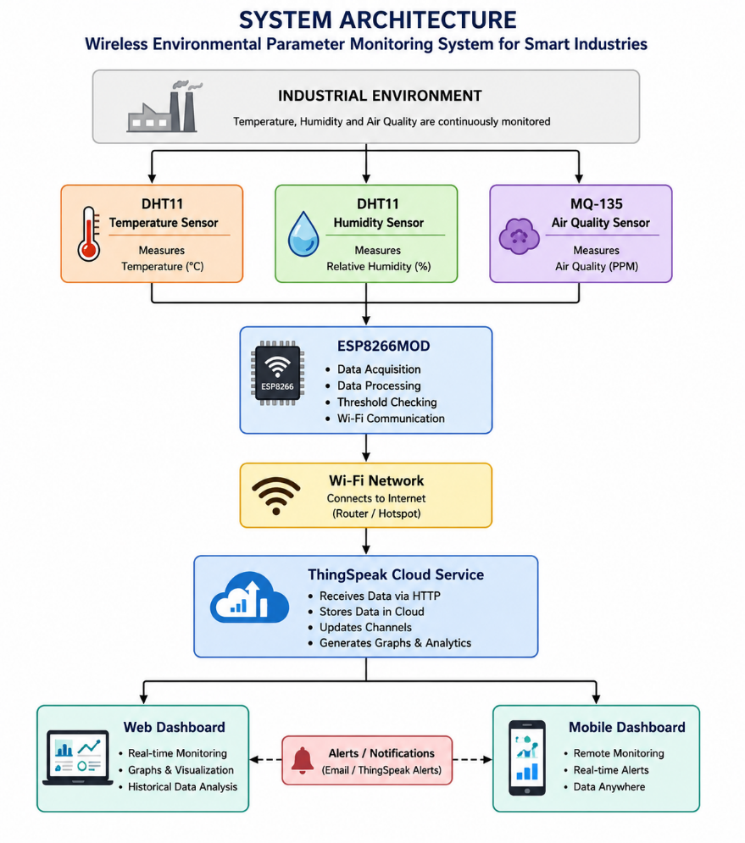

- Circuit Table:

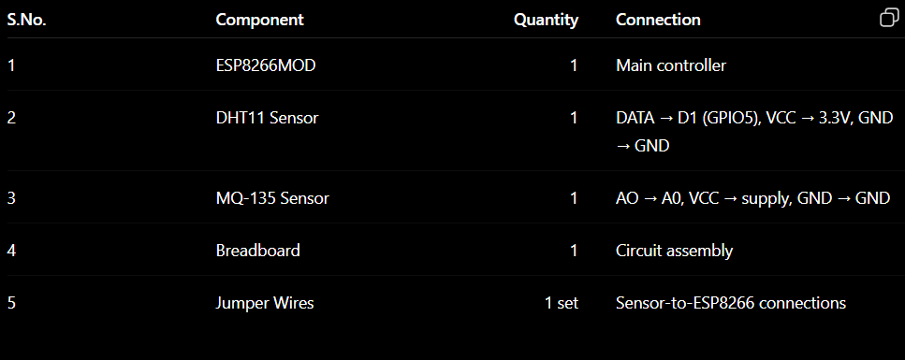

- Circuit Design:

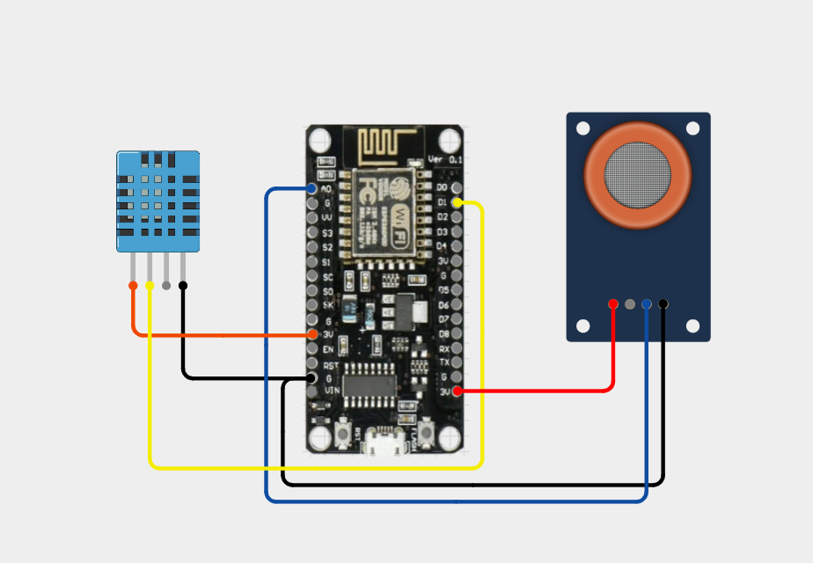

- Algorithm:
Step 1: Start the system.
Step 2: Initialize the ESP8266MOD, DHT11, and MQ-135 sensors.
Step 3: Connect the ESP8266MOD to the configured Wi-Fi network.
Step 4: Read temperature and humidity from the DHT11 sensor.
Step 5: Read the air-quality value from the MQ-135 sensor.
Step 6: Compare the sensor readings with the predefined threshold values.
Step 7: Display the sensor readings and system status on the Serial Monitor.
Step 8: Send the sensor data to the ThingSpeak Cloud using the HTTP API.
Step 9: ThingSpeak stores the data and updates the monitoring graphs.
Step 10: Wait for the predefined interval and repeat the process.

- Coding:

#include <ESP8266WiFi.h>
#include <DHT.h>
#include <ESP8266HTTPClient.h>
#include <WiFiClient.h>

// ================= WIFI =================

const char* ssid = "REALME NARZO 70";
const char* password = "bhav@7686";
const char* thingspeakServer = "http://api.thingspeak.com/update";
const char* writeAPIKey = "N2CDE2KT3OAJ6223";

define DHTPIN 5 // GPIO5 = D1
#define DHTTYPE DHT11

DHT dht(DHTPIN, DHTTYPE);
#define MQ135_PIN A0
float temperatureLimit = 40.0;
float humidityLimit = 80.0;
int airQualityLimit = 600;

void setup() {

Serial.begin(115200);
delay(1000);

Serial.println();
Serial.println("================================");
Serial.println(" Wireless Environmental Monitor ");
Serial.println("================================");

dht.begin();

Serial.println("DHT11 started");

WiFi.begin(ssid, password);

Serial.print("Connecting to Wi-Fi");

while (WiFi.status() != WL_CONNECTED) {

delay(500);
Serial.print(".");
}

Serial.println();
Serial.println("Wi-Fi Connected!");

Serial.print("ESP-12 IP Address: ");
Serial.println(WiFi.localIP());
}

void loop() {

// Read temperature
float temperature = dht.readTemperature();

// Read humidity
float humidity = dht.readHumidity();

// Read air quality
int airQuality = analogRead(MQ135_PIN);

// Check DHT sensor
if (isnan(temperature) || isnan(humidity)) {

Serial.println("ERROR: DHT11 reading failed!");

delay(2000);

return;
}

Serial.println();
Serial.println("-------------------------------");

Serial.print("Temperature : ");
Serial.print(temperature);
Serial.println(" °C");

Serial.print("Humidity : ");
Serial.print(humidity);
Serial.println(" %");

Serial.print("Air Quality : ");
Serial.println(airQuality);

bool alert = false;

// Temperature
if (temperature > temperatureLimit) {

Serial.println("WARNING: High Temperature!");
alert = true;
}

// Humidity
if (humidity > humidityLimit) {

Serial.println("WARNING: High Humidity!");
alert = true;
}

// Air quality
if (airQuality > airQualityLimit) {

Serial.println("WARNING: Poor Air Quality!");
alert = true;
}

if (alert) {

Serial.println("STATUS : ALERT!");

} else {

Serial.println("STATUS : NORMAL");
}

Serial.println("-------------------------------");
if (WiFi.status() == WL_CONNECTED) {

WiFiClient client;
HTTPClient http;

String url = "http://api.thingspeak.com/update?api_key=";
url += writeAPIKey;
url += "&field1=" + String(temperature);
url += "&field2=" + String(humidity);
url += "&field3=" + String(airQuality);

http.begin(client, url);

int httpCode = http.GET();

if (httpCode > 0) {
Serial.print("ThingSpeak Response: ");
Serial.println(httpCode);
} else {
Serial.print("Error sending data: ");
Serial.println(http.errorToString(httpCode));
}

http.end();
}

// Wait 2 seconds
delay(15000);
}

- System Working:

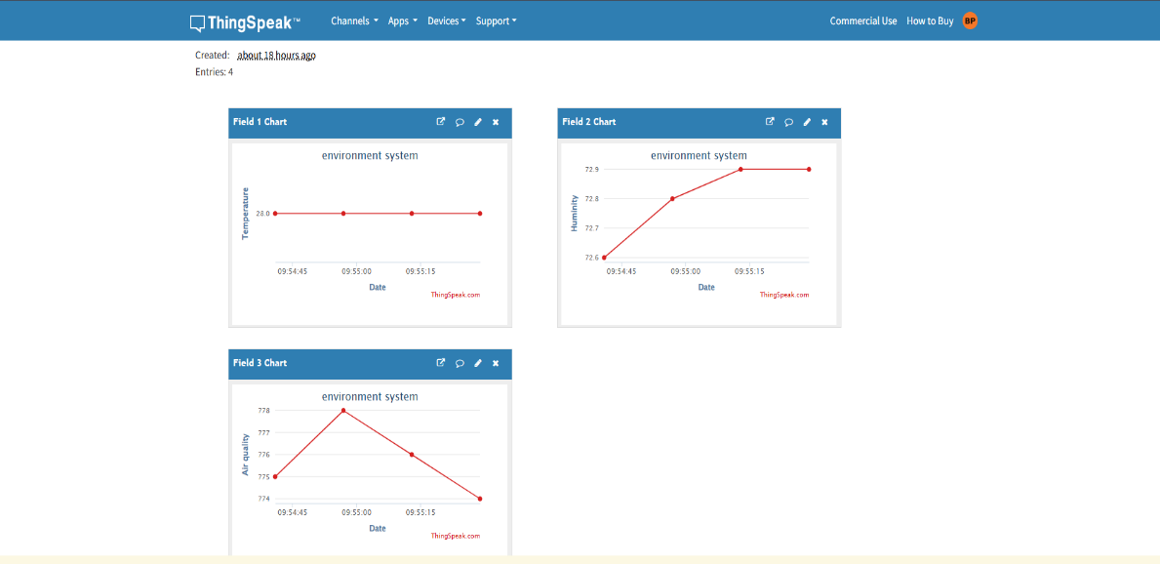

- Working sequence:
Sensing → Processing → Local Display → MQTT Transmission → Cloud Storage → Data Analysis

- Bill of Materials:
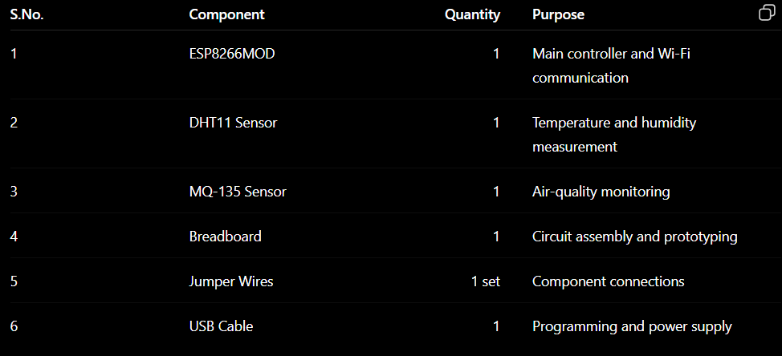

- Prototype Implementation:

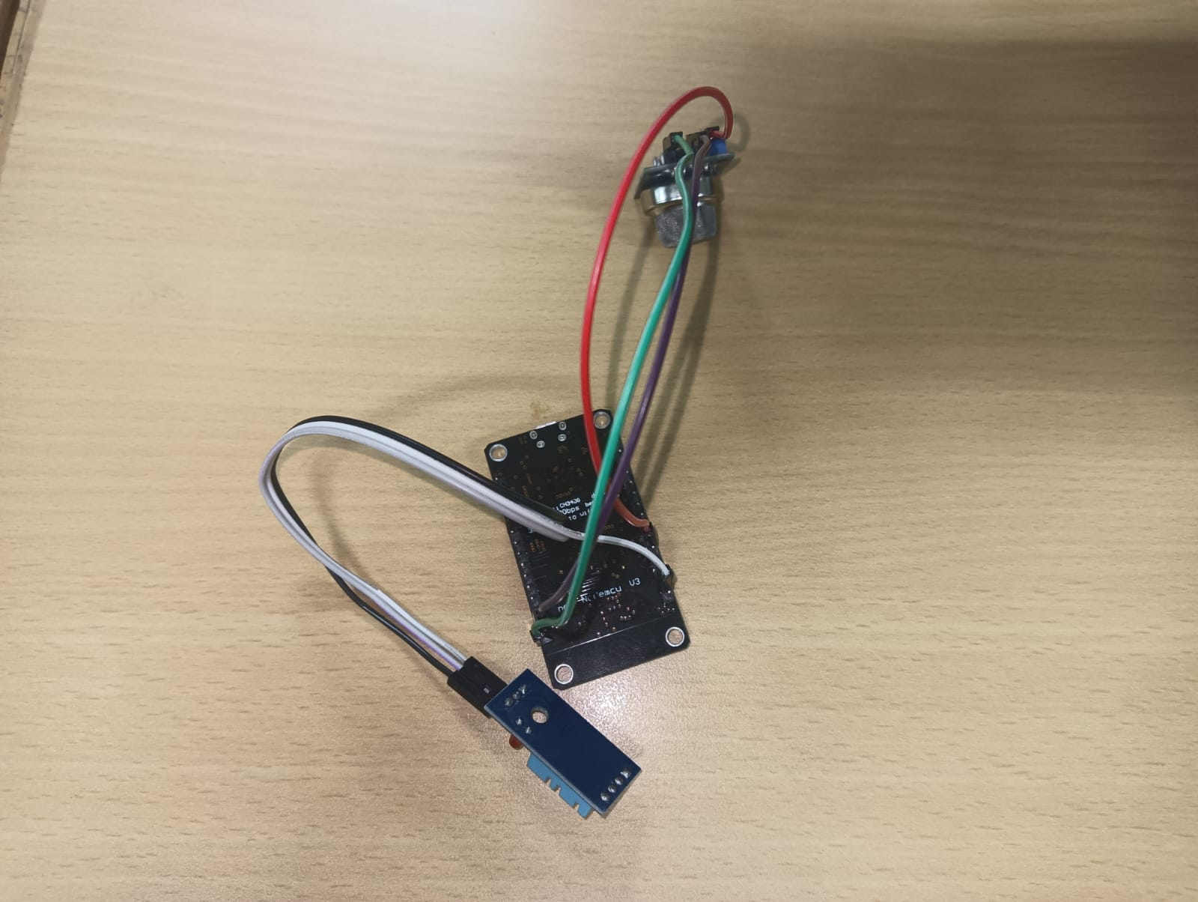

- Results and Performance Analysis:
Performance:
The system provides:
- Real-time temperature monitoring.
- Real-time humidity monitoring.
- Air-quality monitoring using the MQ-135 sensor.
- Wireless data transmission through Wi-Fi.
- Cloud-based data storage using ThingSpeak.
- Historical data visualization through graphs.
- Remote monitoring of industrial environmental conditions.
- Threshold-based environmental status indication.
Advantages:
- Low-cost implementation.
- Simple circuit design.
- Wireless communication.
- Remote monitoring.
- Cloud-based data storage.
- Easy visualization of sensor data.
- Can be expanded for automatic HVAC control.
Limitations:
- DHT11 has limited measurement accuracy compared with industrial HVAC sensors.
- The system depends on Wi-Fi availability.
- The prototype monitors environmental parameters but does not directly control HVAC equipment.
- MQTT/cloud communication depends on Internet connectivity.

